6. Problem–Solution Fit Matrix

Primary User Pain
- People who stammer lack objective, consistent, private feedback on their speech fluency.
- Existing solutions rely heavily on:
  - Human therapists (costly, limited availability)
  - Online Resources
  - Generic speech exercises without measurable progress

Problem Severity
High
- Direct impact on confidence, academic performance, social interaction, and career opportunities.
- Emotional cost (anxiety, avoidance, self-doubt) builds over time.

Solution Relevance (SpeakEase)
High
- Uses speech recording + ML-based analysis to analyze:
  - Repetitions
  - Prolongations
  - Blocks
  - Fluency rate over time
- Provides judgment-free practice using exercises , and builds confidence by using role-play chats .

Problem–Solution Mapping
Pain Point | Severity | SpeakEase
No measurable fluency tracking / progress | High | Fluency score & trend tracking
Therapy access is limited | High | Self-guided / self paced practice
Fear of judgment while practicing | High | Private, solo practice
Inconsistent feedback | Medium | Standardized ML-based evaluation

Primary pain addressed: Lack of measurable, fluency feedback and confidence

7. Competitive Landscape & App Store Audit

Direct Competitors
- Speech therapy apps focused on exercises
- Apps offering guided pronunciation practice

Indirect / Substitute Competitors
- In-person speech therapists
- YouTube speech therapy videos

Competitive Gaps Identified

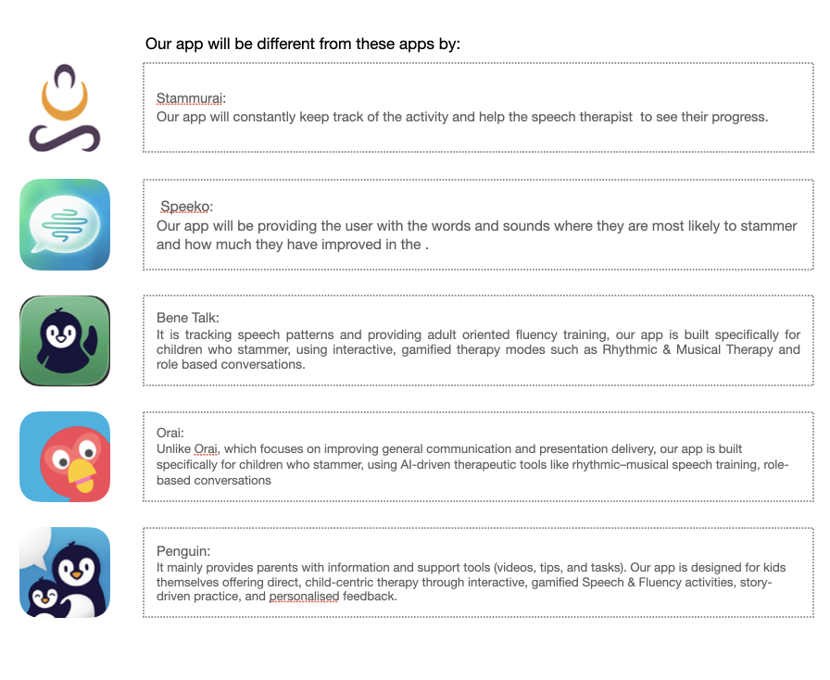

App Store Observations
- Most apps emphasize exercises, not outcomes
- User complaints often mention:
  - “I don’t know if I’m improving”
Differentiation
SpeakEase positions itself as a fluency measurement and feedback tool, not just an exercise app.

8. Value Proposition Canvas (User-Side Focus)

User Jobs
- Practice speaking without fear
- Track improvement objectively
- Build confidence before real conversations

User Pains
- Embarrassment when practicing with others
- Uncertainty about progress
- Inconsistent feedback

User Gains
- Clear understanding of fluency level
- Motivation through visible improvement
- Control over pace and privacy
- Confidence through data, not guesswork

SpeakEase Pain Relievers
- ML-based speech analysis
- At-home, on-demand practice
- Progress tracking with fluency score
- Confidence building while practicing

SpeakEase Gain Creators
- Fluency score
- Progress tracking
- Personalized feedback patterns

Validated Value Proposition Statement
SpeakEase enables people who stammer to objectively measure and improve their speech fluency through ML-driven analysis reducing uncertainty, anxiety, and building confidence.

